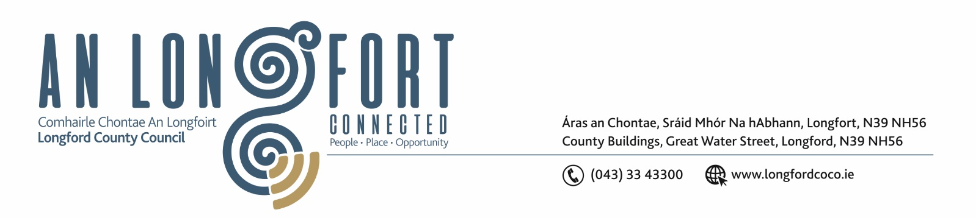

9th November 2020.

Chuig: Gach Ball don Chomhairle.

A Chomhairleoir,

You are requested to attend the Statutory Local Authority Budget Meeting of Longford County Council to be held in Longford Rugby Club, Demesne, Longford/via Microsoft Teams on Monday, 23rd November 2020 at 3.00 p.m. to transact business as set out on the agenda hereunder.

Mise le meas,
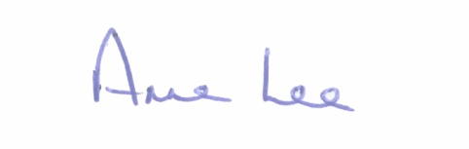

________________
Anne Lee,
Meetings Administrator.

C L A R

Prayer before meeting.

- Consideration of 2021 Draft Budget - enclosed.



